

NATIONAL UNIVERSITY OF TECHNOLOGY
(Department of Computer Science)
CS161– Database Systems
Instructor: Miss Faiza khan
Name: Bisma Fatima
Roll no: f24605036

LAB TASK 11

In Lab Tasks
Database Structure Overview
∙ Books(BookID, Title, Author, ISBN, Price, StockQuantity)
∙ Customers(CustomerID, Name, Email, Address)
∙ Orders(OrderID, CustomerID, OrderDate, TotalAmount)
∙ OrderItems(OrderItemID, OrderID, BookID, Quantity, Price)
Task 1: Creating and Querying a Simple View
Expalantion of creating view:
A view is a virtual table based on a SQL query. You create it using CREATE VIEW to simplify data retrieval, and you can query it just like a table using SELECT.
- Write a SQL CREATE VIEW statement to create a view named ActiveCustomers that shows CustomerID, CustomerName, and Country for all customers where IsActive = 1.
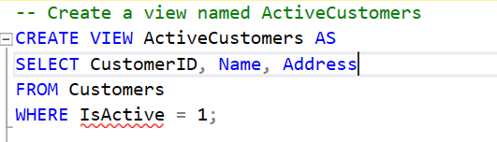

- Write a SQL SELECT query to retrieve all records from the ActiveCustomers view.
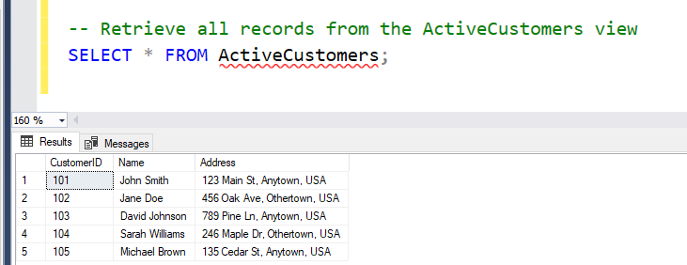
Task 2: Updating and Dropping Views
Explanation of dropping and update view:
Use CREATE OR ALTER VIEW to update an existing view without dropping it, or DROP VIEW to remove it from the database when it’s no longer needed.
- Write a SQL CREATE OR ALTER VIEW statement to update the ActiveCustomers view to also include the Email column.
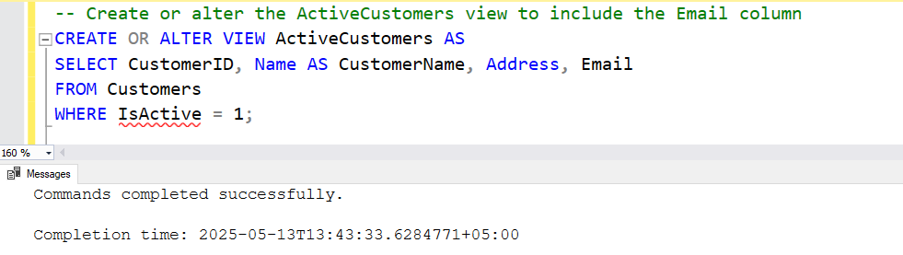

- Write a SQL statement to drop the ActiveCustomers view.
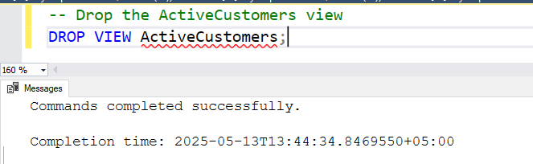
Task 3: Creating and Using Indexes
Explanation of creating indexes:
Indexes improve search speed in tables. You create them using CREATE INDEX for faster lookups, and unique indexes (CREATE UNIQUE INDEX) prevent duplicate values.

- Write a SQL CREATE INDEX statement to create a non-unique index named idx_Author on the Author column of the Books table.
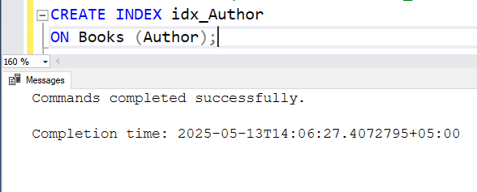
- Write a SQL CREATE UNIQUE INDEX statement named idx_ISBN on the ISBN column of the Books table.
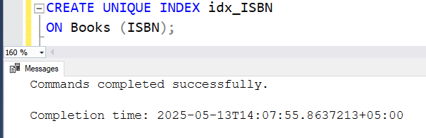
- Write a SQL DROP INDEX statement to remove the idx_Author index from the Books table.
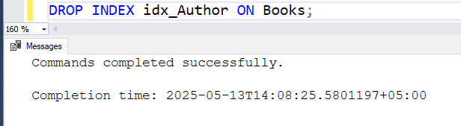
Task 4: Querying with Indexes
Explanation of dropping view:
Queries benefit from indexes by reducing search time. Instead of scanning the entire table, an indexed column allows SQL to retrieve data more efficiently.

- Write a SQL SELECT query to find all books written by the author 'John Doe' from the Books table.
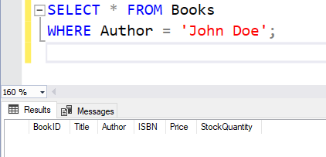
- Explain briefly how the index on Author helps speed up this query.
ANS:
An index on the Author column allows the database to quickly locate relevant records instead of scanning the entire Books table. Since indexes store values in a structured format, searches for books by a specific author become much faster, reducing query execution time and improving overall performance.

Task 5: Understanding Functional Dependencies

- Using the Books table, write a SQL SELECT query to get all details for a book with BookID = 1.
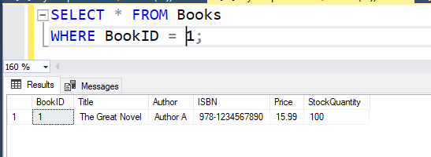
- Explain in one sentence what functional dependency exists between BookID and Title.
ANS:
A functional dependency exists between BookID and Title because each BookID uniquely determines a single Title, ensuring no two books share the same identifier.

- Given that BookID determines Title and Title determines Author, explain what functional dependency exists between BookID and Author.
ANS:
BookID determines Title, and Title determines Author, there is a transitive functional dependency between BookID and Author, meaning that BookID indirectly determines Author through Title.

Post Lab Tasks
Task 1
Report Generation:
Write a report that includes:
- The SQL queries written for the In-Lab tasks.
- The output of each query (screenshots from your SQL database management system).
- A brief explanation of each query and its purpose.
Task 2
Applying Functional Dependency Rules (Short Answer) add in report
- Describe the Reflexive Rule of functional dependencies in your own words.
ANS:
Reflexive Rule (Trivial Functional Dependency) If a set of attributes X includes an attribute Y, then X → Y holds true. In simple terms, an attribute is always functionally dependent on itself or a subset of itself. Example: If we have (ProductID, ProductName) as attributes, then ProductID → ProductID is trivially true
- Describe the Augmentation Rule with an example.
ANS:
Augmentation Rule If X → Y holds, then adding another attribute Z to both sides still maintains the dependency: XZ → YZ. Example: Suppose CustomerID → CustomerName holds, meaning CustomerID uniquely determines CustomerName. If we augment with OrderID, then (CustomerID, OrderID) → (CustomerName, OrderID) remains valid.

- Describe the Transitive Rule with an example.
ANS:
Transitive Rule If X → Y and Y → Z, then X → Z also holds. Example: If BookID → Title (BookID uniquely determines Title) and Title → Author (each Title corresponds to an Author), then we can conclude BookID → Author, showing a transitive dependency.

